**27.Use Figma to create an interactive presentation comparing the Core Video framework in iOS and the multimedia framework in Android.**

**Aim:** Create an interactive presentation comparing the Core Video framework in iOS and Android using Figma

**Procedure:**

1.Define Presentation Structure

2.Create a Figma Project

3.Design Visual Elements

4.Make it Interactive

5.Add Annotations and Explanations

6.Incorporate Multimedia

7.Storyboard Animation

8.Test the Prototype

9.Collaborate and Gather Feedback

10.Finalize and Share

**Design:**

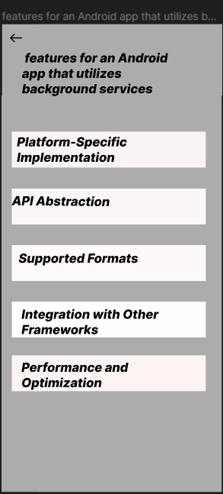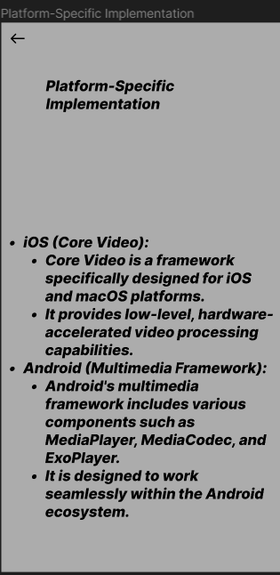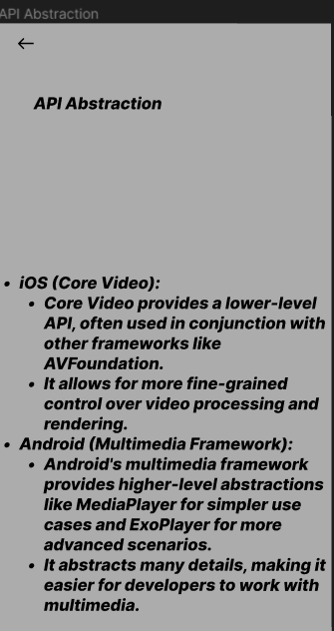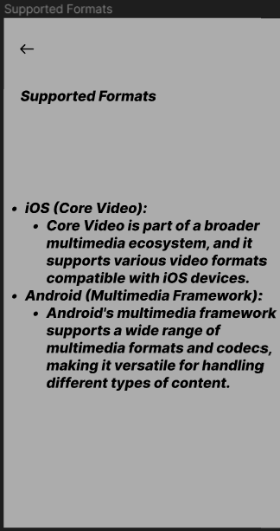

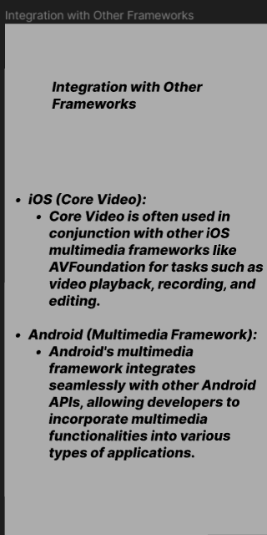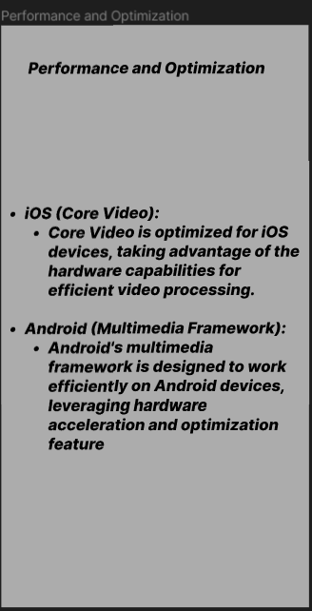

Prototype:

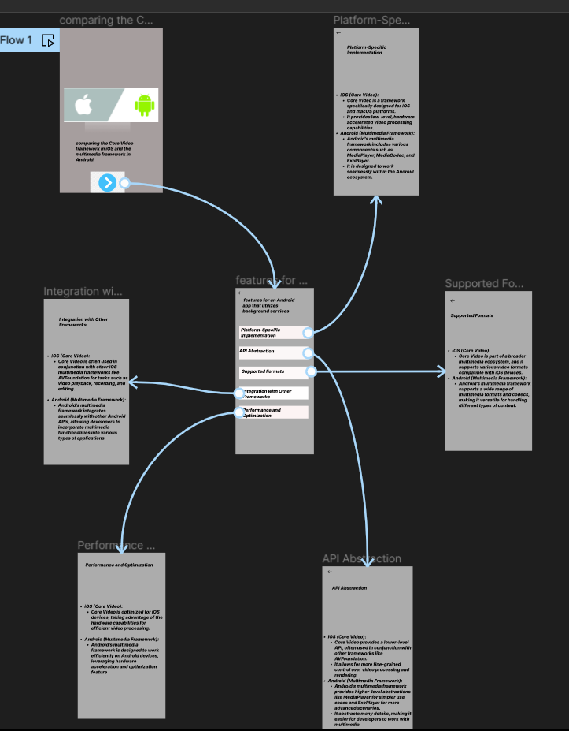

**Result:** Hencean interactive presentation comparing the Core Video framework in iOS and Android using Figma have been created successfully.